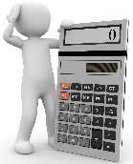 | Operatio

1 |  | 2 |  | 3 |  | 4 |  | 5 |  | 6
7 |  | 8 |  | 9 |  | 10 |  | 11

+
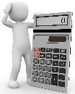 | Operatio | 1
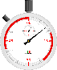 1 min
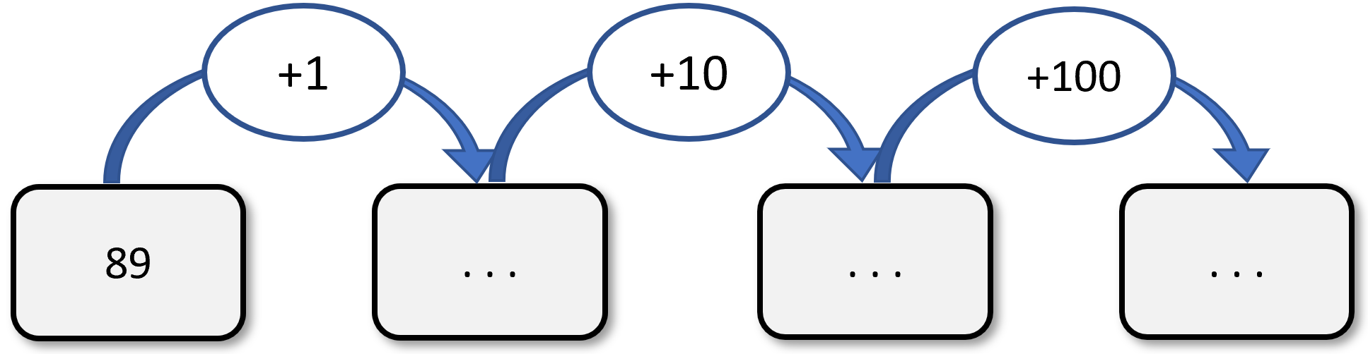
+
 | Operatio | 2
1 min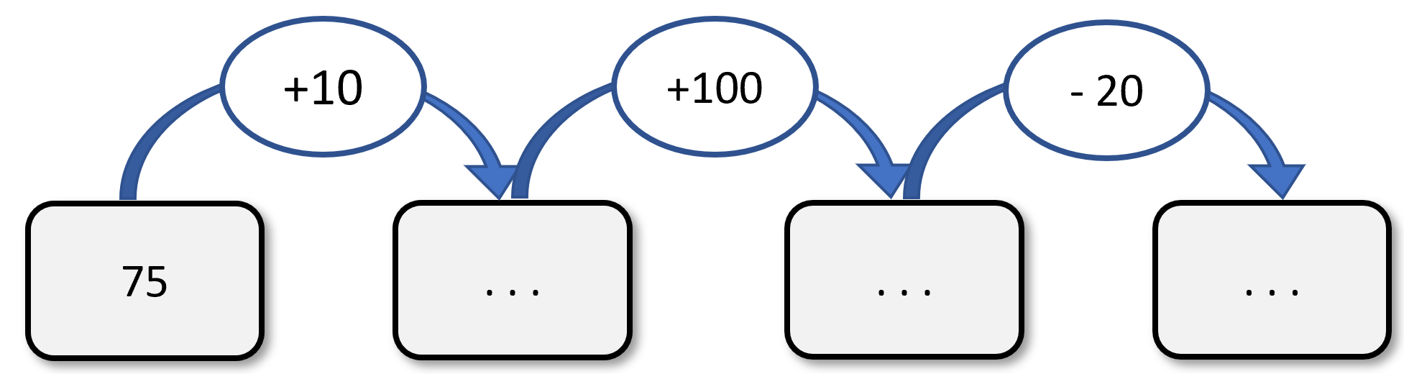

+
 | Operatio | 3
2 min
72 + 20 = . . . | 23 + 19 = . . .
43 + 10 = . . . | 94 + 19 = . . .
38 + 11 = . . . | 1 98 + 11 = . . .
18 + 19 = . . . | 709 + 11 = . . .

+
 | Operatio | 4
1 min
64 + 11 = . . . | 62 – 11 = . . .
33 + 11 = . . . | 78 – 11 = . . .
175 + 11 = . . . | 46 – 11 = . . .
105 + 11 = . . . | 71 – 11 = . . .

+
 | Operatio | 5
1 min
34 + 9 = . . . | 84 – 9 = . . .
43 + 9 = . . . | 49 – 9 = . . .
22 + 9 = . . . | 63 – 9 = . . .
100 + 9 = . . . | 70 – 9 = . . .

+
 | Operatio | 6
2 min
Double de 5 : . . . | Double de 15 : . . .
Double de 6 : . . . | Double de 25 : . . .
Double de 11 : . . . | Double de 50 : . . .
Double de 20 : . . . | Double de 100 : . . .

+
 | Calculus | 7
1 min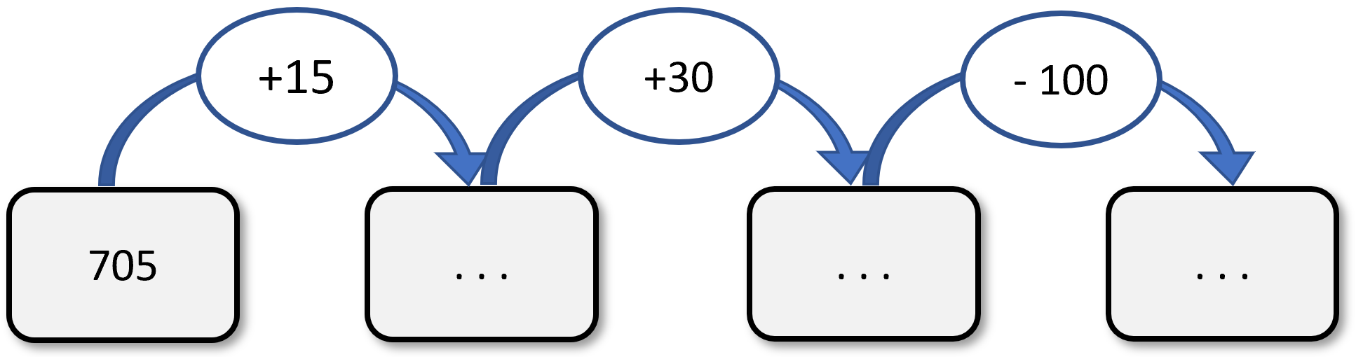
+
 | Calculus | 8
2 min
104 + 9 = . . . | 614 – 9 = . . .
703 + 9 = . . . | 429 – 9 = . . .
372 + 9 = . . . | 613 –9 = . . .
188 + 9 = . . . | 721 –9 = . . .

+
 | Calculus | 9
1 min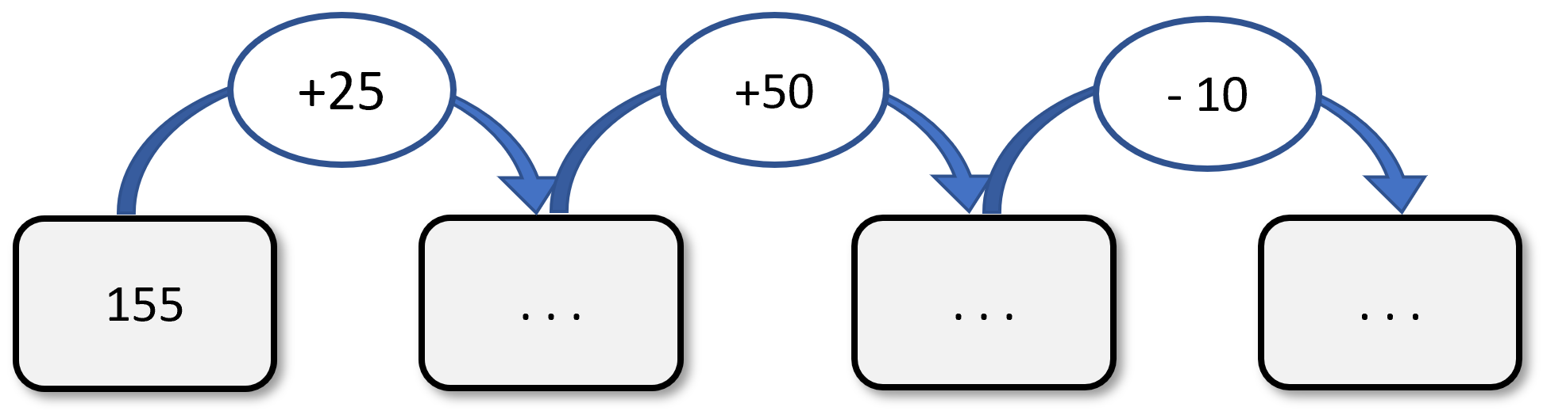
+
 | Calculus | 10
1 min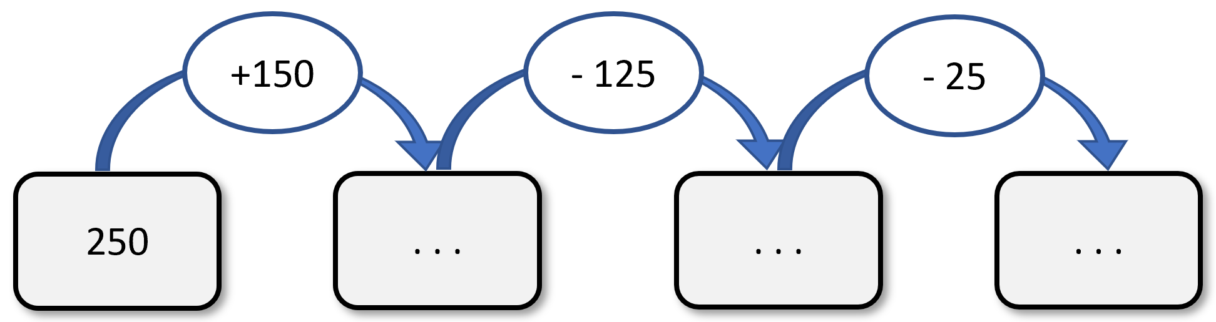
+
 | Calculus | 11
1 min