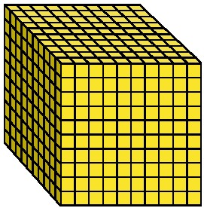 | 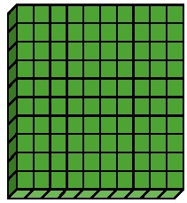 |  | 
mille | centaine | dizaine | unité
M | C | D | U

